
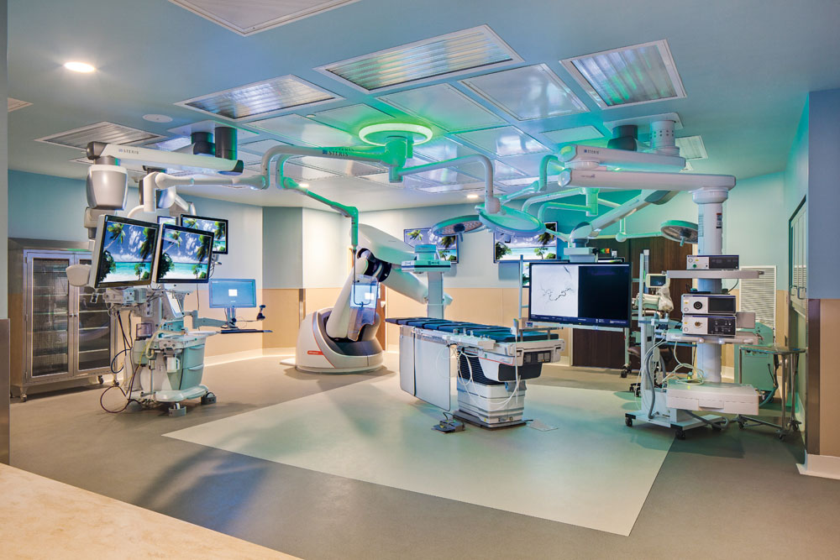
GENERAL SURGERY RESIDENCY

October 2024

BAPTIST MEMORIAL MEDICAL EDUCATION
Stephen Behrman, MD FACS | Program Director

Table of Contents

Mission, Vision, & Values 1

General Surgery Residency 2

About Us: 2

Sports and Outdoor Activities 3

Memphis Sports 3

Shelby Farms 3

The Greenline – walk, run, bike 4

About Us: General Surgery Residency Program 5

PD, APD, Chair, Core, PC 5

New General Surgery Residency Suite 6

Surgical Innovation at Baptist 6

da Vinci Surgical System 6

Hybrid Surgical Suites 6

General Surgery 7

Hepato-biliary-pancreatic surgery 7

Minimally invasive surgery 7

Surgical Oncology 7

Acute Care Surgery 7

ENT 7

Vascular Surgery 8

Pediatric surgery 8

Other Surgical-Based Services 8

Transplant 8

Mechanical Circulatory Support (MCS) 8

Neurosurgery 9

Ophthalmic Surgery 9

Orthopedic Surgery 9

Plastic & Reconstructive Surgery 10

Block Schedule 11

About Us: Baptist Memorial Hospital-Memphis 12

Resources 12

Baptist Memphis Education Center 12

Dr. H. Edward Garrett, Sr. Auditorium 12

Libraries 13

Maury W. Bronstein Health Sciences Library 13

Ann L. and Joseph H. Powell Library (BMH-Memphis) 14

Research 15

Baptist Clinical Research Institute 15

Baptist Institutional Review Board 15

Baptist Cancer Center 15

Other Baptist Research Sites 15

About Us: Our Partner Sites 17

Baptist Memorial Hospital – DeSoto 17

Baptist Memorial Hospital for Women and the Baptist-Spence and Becky Wilson Children’s Hospital 17

Baptist Memorial Hospital – Union County 17

Vanderbilt University Medical Center 18

Your 2025 Benefits Options 19

SELECTED GME POLICIES 20

Baptist Memorial Health Care

Mission, Vision, & Values
MISSION
In keeping with the three-fold ministry of Christ – Healing, Preaching and Teaching – BMHCC is committed to providing quality health care.
VISION
We will be the provider of choice by transforming the delivery of health care through partnering with patients, families, physicians, care providers, employers and payers; and by offering safe, integrated, patient focused, high quality, innovative cost-effective care.
VALUES
Compassionate Care and Service; Teamwork and Trust; Innovation and Excellence; Respect for the Individual and the Value of Diversity.

Graduate Medical Education Mission Statement
In accordance with the Baptist Memorial Health Care Corporation mission of healing, preaching, and teaching, Baptist Memorial Medical Education provides excellent education and quality patient care through oversight, guidance, instruction, and assistance to the faculty and learners we serve.

General Surgery Program Mission Statement
To graduate excellent surgeons who deliver outstanding quality-based, outcome-driven, patient-centered care by achieving their maximal potential through academic and clinical training and research.

Baptist Memorial Medical Education
General Surgery Residency Program
Our program is based at Baptist Memorial Hospital-Memphis (BMH-Memphis) with required rotations at BMH-DeSoto, BMH-Union County, BMH for Women, and Vanderbilt University Medical Center (VUMC). During your time with us, you will experience progressing training with nationally-renowned physician staff in all areas of surgical care to ensure that you are well-prepared to practice independently at completion of your residency or, should you choose, to enter subspecialty training in furtherance of your career choice.
Please visit our website at https://bmme-generalsurgeryresidency-memphis.org/
But before we get started, here’s a little something about the Memphis area and the Baptist system.
About Us: Metropolitan Memphis Area (i.e. The MidSouth)
Memphis, Tennessee is a diverse city located where Arkansas, Mississippi and Mississippi meet. It is the largest city in the Deep South, third largest in the Southeastern United States, and eighth largest in the Southern United States as a whole. It’s location near the center of the United States based on population distribution, has brought many Fortune 500 and Fortune 1000 companies to our area including FedEx, AutoZone, and International Paper. There is an Amazon Distribution Center in one of our suburbs. Our lower than average Cost of Living, especially in today’s housing market, allows us to live well above the American average. Memphis sits on the banks of the Mississippi River and experiences four distinct seasons, ranging from sun-soaked summer months to crisp winters without much snow. Summers can be humid, as warm, wet air comes up from the Gulf of Mexico with mild winters that sometimes dip below freezing. On average, there are 218 sunny days per year in Memphis, Tennessee with an average July high of 91 degrees and average January low of 31.

“Nowhere on earth can you find our one-of-a-kind attractions built around the music that flows from very street corner. Our culinary options serve up everything from world famous barbecue plus a smorgasbord of flavors from eclectic neighborhoods.
The soul of the city is forged with the current of the Mighty Mississippi River. From attractions to dining to outdoor adventures, the magic of Memphis is in the mix.
Beale Street at Night
Not only do we get it, but the world does too. Many of our attractions were voted number one in USA Today’s 10 Best lists including Graceland, National Civil Museum, Memphis Zoo, Sun Studio and Stax Museum of American Soul. Money Magazine named Memphis #3 Most Affordable Destination and Fodor’s listed the city as the #6 destination on their 2018 ‘Go List’.” FROM www.memphistravel.com

Sports and Outdoor Activities

Memphis Sports
If you are a sports fan, you’ll be delighted to know that we are home to an NBA basketball franchise, the Memphis Grizzlies; an AAA baseball team, Memphis Redbirds; a United Soccer League, Memphis 901 FC; and, of course, the FedEx St. Jude Invitational golf event. We host events at the Liberty Bowl Stadium including the home games for the University of Memphis Tigers and the Southern Heritage Classic.

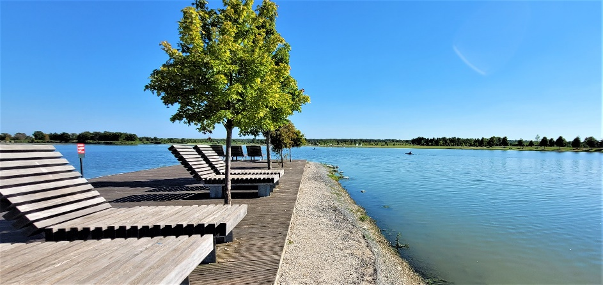
Shelby Farms
Lounge next to Patriot Lake
Some of my personal favorite outdoor activities are all available in Shelby Farms Park located adjacent to Baptist Memorial Hospital-Memphis.
Shelby Farms has really gotten noticed:
- The American Institute of Architects 2019 Regional & Urban Design award
- 2018 TripSavvy Editors’ Choice Award for Family Attractions and Experiences

- Subject of “Shelby Farms Park: Elevating a City” which won the Gold Medal from the Independent Publisher Book Awards in the ‘South – Best Regional Non-faction’ category

Shelby Farms is one of the largest urban parks in the country at 4,500 acres – more than five times larger than Central Park in NYC. The park includes forty miles of trails popular for walking, biking, running, and hiking and twenty bodies of water providing lots of fishing opportunities. The Baptist Memorial Health Care Promenade is a 2.34 mile paved path around Hyde Lake in Shelby Farms Park. The park also has restaurants, an entertainment stage, an award-winning playground, water play/splash area, dog park (and leashed dogs are welcome in all outside areas of the park), horseback riding, zip-lining, paintball, laser tag, Frisbee golf, a free (golf) driving range, and a 50 acre range for our small herd of buffalo which averages about fifteen head.
Protected areas within Shelby Farms
Super-dog kayaking on a sunny day

The Greenline – walk, run, bike
Shelby Farms Greenline is a 10.65-mile and growing paved, urban trail that connects pedestrians and cyclists in Midtown Memphis through Shelby Farms Park to Cordova. It is a rails-to-trails project that transformed an unused railroad line into one of Tennessee’s favorite trails.
If your bike needs a little work while you’re on the trails, you can visit one of the four free bike repair stations on the Greenline and in the Park where you will find all the tools you need to keep on cruising. Shelby Farms supports the Greenline by offering bike rentals for adults and children - including e-bikes! There is even a BMX Track with novice, intermediate, and expert levels available.
- Outside of the Shelby Farms Greenline, Memphis has lots and lots of bike trails including:
- Meeman-Shelby Forest State Park - a five mile intermediate trail with flat areas, smooth pavement, switchbacks, and great turns.
- Mississippi River Trail – 32-mile segment that passes through Shelby County, including Meeman-Shelby Forest, through Downtown Memphis, across the Mississippi River and into Arkansas.
- Overton Park, in MidTown Memphis, has nearly 200 acres or parkland, including the famous Memphis Zoo, and a 2.5-mile winding, shaded bike path, two play areas, and a dog park.
More info about Memphis is available through Memphis Tourism at https://www.memphistravel.com/
For more information about Shelby Farms and the Greenline, click https://www.shelbyfarmspark.org/
Cost of Living info can be found on many sites - just Google “Memphis Cost of Living”

About Us: General Surgery Residency Program
Our surgical residency program gained accreditation from the Accreditation Council for Graduate Medical Education (ACGME) in April 2021. As a new program, we recognize that some applicants may consider our program with apprehension. Please allow us to put your fears to rest. As our Institutional Sponsor, Baptist Memorial Medical Education (BMME) has overseen residency programs for nearly one hundred years. In addition to our program, BMME has led several other new programs to gain recent accreditation, including the Addiction Medicine and Geriatric Medicine fellowships here at BMH-Memphis, as well as two Family Medicine programs and the Internal Medicine programs in three of our regional hospitals. These experiences have allowed BMME to provide insight and support for this program and will help to alleviate any issues that may arise.
Most importantly, our program administration and faculty have vast experience in Medical Education. Just take a look below at the experience for a few of our program administrators.

PD, APD, Chair, Core, PC
Below is some very brief information about our leadership team. For more information, please visit our website at https://bmme-generalsurgeryresidency-memphis.org/Faculty
Stephen Behrman, MD | 29 years’ experience in GME
- Program Director, General Surgery, BMME 2024-Present
- Chair of Program & Core Faculty, Gastrointestinal Surgery, BMME 2018-Present
- Assistant Professor through Professor of Surgery, UTHSC 1997-2020
- Assistant Clinical Professor of Surgery, University of San Francisco/ Fresno-Central 1995-1997
Nathaniel Stoikes, MD | 13 years’ experience in GME
- Associate Program Director, General Surgery, BMME 2019-Present
- Adjunct Faculty, University of Memphis, BioEngineering Dept 2014-Present
- Assistant Clinical Professor through Associate Professor of Surgery, UTHSC 2011-Present
David Webb, Jr., MD | 112years’ experience in GME
- Associate Program Director, General Surgery, BMME 2018-Present
- Assistant Clinical Professor of Surgery, UTHSC 2012-Present
Ahmad Abdulkarim, MD, PhD | 22 years’ experience in GME
- Clinical Instructor, General Surgery, BMME 2018-Present
- Associate Professor of Surgery, VA Hospital & UTHSC 2017-Present
- Associate Professor, Transplant Surgery, University of S Dakota 2014-2017
- Assistant Professor through Associate Professor of Surgery, University of Kansas 2013-2014
- Vice Chair – Clinical Affairs, University of Kansas 2010-2013
- Surgical Director, Abdominal Transplant, University of Kansas 2007-2010
Guy Voeller, MD | 37 years’ experience in GME
- Core Faculty and Clinical Instructor, Minimally Invasive Surgery (MIS), BMME 2018-Present
- Associate Professor through Professor of Surgery, UTHSC 1994-Present
- Assistant Professor of Anesthesiology, UTHSC 1989-1994
- Instructor through Assistant professor of Surgery, UTHSC 1987-1994
Brad Wolf, MD | 25 years’ experience in GME
- Clinical Instructor, General Surgery, BMME 2018-Present
- Assistant Professor of Surgery and Medical Student Mentor, UTHSC 1999-2018
Shaun Stickley, MD | 12 years’ experience in GME
- Program Director, General Surgery, BMME 2019-2024
- Program Director, General Surgery, UTHSC 2016-2018
- Assistant Professor of Surgery, Vascular Surgery, UTHSC 2012-2018

New General Surgery Residency Suite
The General Surgery Residency program at BMH-Memphis is currently transforming 2400 ft of office space contiguous to the hospital into the new space for our program. This new area will include a simulation center, resident work room, resident lounge, business center, conference room, locker room, two call/ lactation rooms, and offices for program administration.

Surgical Innovation at Baptist

da Vinci Surgical System
In 2003, Baptist Memphis became the first hospital in the Mid-South to purchase the da Vinci robot system. Complementary systems were added on our DeSoto campus, and the North Mississippi (Oxford, MS) and Women’s hospitals. In 2021, a second system was added to our flagship hospital. The daVinci systems receive active utilization in colorectal, gastrointestinal, thoracic, urologic, gynecologic and cardiac operations. Residents will gain exposure and graduated proficiency in this leading technology.

Hybrid Surgical Suites
Hybrid surgical suite: In early 2020, Baptist opened our 2nd hybrid operating suite utilized by vascular and cardiac surgeons. Procedures commonly performed in these complex suites include angioplasty, stent placement and heart valve replacement (TAVR).

General Surgery

Hepato-biliary-pancreatic surgery
Baptist faculty perform the majority of HPB, gastric, and esophageal surgery in the region. Operative procedures for benign and malignant disorders of the liver and pancreas exceed 50 and 100 respectively each year. We regularly receive bile duct injuries and other biliary disorders from our four-state area. This allows the resident to gain vast knowledge in the pathophysiology of these index cases and experience in the perioperative management of these complex patients. Our surgical team is supported by expert colleagues including interventional radiologists, gastroenterologists, medical and radiation oncologists, pathologists, and genetic counselors.

Minimally invasive surgery
Our faculty pioneered MIS surgery in the Mid-South and are nationally-known leaders in this area. Advanced laparoscopic and robotic procedures are utilized for esophageal, splenic, adrenal, colorectal, and other disorders. The resident will gain exposure and proficiency in these and other more routine MIS procedures in a high volume center utilizing the most advanced instrumentation and video optics in two dedicated MIS surgical suites.

Surgical Oncology
In addition to HPB surgery, our faculty has expertise in all disciplines of cancer surgery including melanoma, sarcoma, breast, colorectal, and peritoneal-based diseases including HIPEC. The wide breadth of exposure to these oncologic procedures can be duplicated in few centers.

Acute Care Surgery
Residents will gain exposure to assessing patients with acute surgical conditions in the Emergency Room. This high volume program will allow the trainee to gain significant experience and judgement in routine surgical emergencies including appendicitis, cholecystitis and diverticulitis, as well as obstruction of the small and large bowel. We also consult with surgeons from other disciplines for general surgical conditions that may mandate operative intervention.

ENT
Through very close mentorship, residents will have a wide exposure to both routine and complex head and neck pathology. They will gain knowledge in anatomy, diagnostic evaluation, and the surgical approach to these often complex cases including thyroid and parathyroid pathology, as well as head and neck cancers.

Vascular Surgery
Our expanding vascular surgery division offers the opportunity to apply knowledge-based learning to a high volume practice that includes the most advanced catheter-based and open procedures in state-of the-art surgical suites. Residents can expect to gain an early “hands on” experience in assessment of the vascular tree in the clinic and the operating room.

Pediatric surgery
The Baptist-Spence and Becky Wilson Children’s Hospital located adjacent to Baptist Memorial hospital for Women on the BMH-M campus provides many surgical services for our pediatric population. Our 24/7 Pediatric Surgeons and Specialty/ subspecialty surgeons perform general surgical procedures as well as procedures in ENT, GI, Gyn, Ophthalmology, Ortho, Plastics, and Urology.

Other Surgical-Based Services

Transplant
2024 marks the 39th year medical professionals at Baptist have performed heart transplants. Since the program began, surgeons have performed over 402 heart transplants.
The nationally renowned team, led by program director Dr. Todd Edwards, consistently achieves some of Tennessee’s best outcomes for heart transplants. Recent heart transplant data show 91.7% of Baptist’s patients are alive one year after their transplant.

Mechanical Circulatory Support (MCS)
The Baptist Mechanical Circulatory Support (MCS) Program offers leading-edge devices that can be used as rescue therapy for patients with advanced heart failure. Device therapy, such as Extracorporeal Membrane Oxygenation, CentriMag, intra-aortic balloon pump, and Impella, can provide patients a bridge to recovery, serve as long-term device therapy, or be used until transplantation.
Extracorporeal Membrane Oxygenation (ECMO) – This device supports patients who are in severe heart or lung failure and are unresponsive to optimal conventional care. While a patient’s circulation and/or respiration are being supported by ECMO, the failing organs are being treated, recovered or replaced. ECMO has also been used very successfully during the COVID-19 pandemic.
CentriMag (CMAG) – For temporary ventricular support, a CMAG is used for patients who fail to come off cardiopulmonary bypass or as a bridge to allow medical staff to decide on the best options for long-term support. It can provide more than nine liters of blood flow to the heart and can be used for 30 days or more.
Intra-aortic balloon pump (IABP) – Using a balloon placed in the aorta through the axillary or femoral artery, this device decreases oxygen demand on the heart and increases oxygen supply. It is a short-term mechanical device that is typically inserted through the groin and helps the heart pump blood to the body more efficiently and supply blood to the blood vessels in the heart.
Impella – An Impella is used for temporary ventricular support in patients with depressed heart function. Typically inserted through the groin, this short-term mechanical device provides more support than an IABP. This device can also stay in place longer than an IABP. It is mostly used in high-risk heart catheterizations to provide support when placing stents in critical vessels.
Tandem heart – This device is used for temporary support to decrease the size of the left or right ventricle, thereby reducing the workload of the heart. It can provide up to five liters of blood flow to the heart.
Long-term ventricular assist devices (LVAD) –An LVAD is a small, mechanical pump implanted inside the chest or abdomen that takes over the job of the weak left ventricle. Blood flows from the left ventricle through an inflow tube to the pump, then the pump pushes the blood through an outflow tube into the aorta.
An LVAD can be a temporary treatment until a heart transplant becomes available, or used as long-term therapy if transplant is not an option. Baptist has implanted more than 360 VADs since 1996 and holds The Joint Commission Disease Specific Certification for Destination Therapy VAD.

Neurosurgery
Neurosurgery specialists at Baptist Memorial Health Care provide a broad range of surgical services for the diagnosis, treatment, and rehabilitation for brain, spinal cord, and peripheral nerve diseases and disorders. Under the guidance of our neurosurgeons and specialists, Baptist treats a variety of conditions in adults and children.

Ophthalmic Surgery
The highly trained and nationally-recognized ophthalmic surgeons practicing at Baptist Memorial Hospital for Women and Children perform procedures for both adults and children.

Orthopedic Surgery
Baptist embraces our common goal of providing world class orthopedic care wrapped in an indisputably exceptional experience to patients across the Mid-South region. Orthopedic surgical training encompass the entire body from Spine to Hand & Wrist to Foot & Ankle.

Plastic & Reconstructive Surgery
The Baptist Cancer Center has long worked to enhance the quality of life for cancer patients with the same multidisciplinary approach that has made Baptist Cancer Center a leader in treating cancer. Our clinical faculty are experts in state-of-the-art micro-vascular surgical techniques to achieve the best possible outcomes.

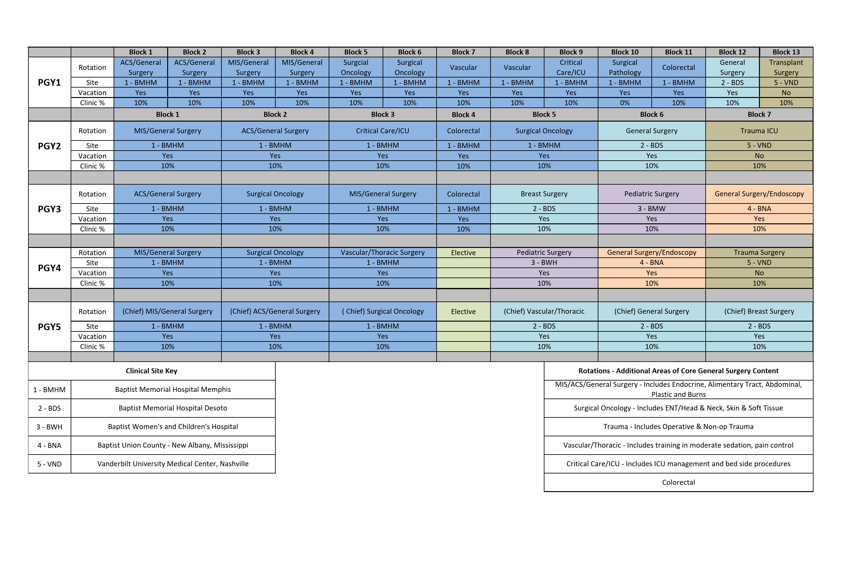
Block Schedule

About Us: Baptist Memorial Hospital-Memphis
Baptist Memorial Hospital-Memphis is the flagship hospital of Baptist Memorial HealthCare Corporation (BMHCC). Our first hospital was built in 1912 in what was to become the Medical Center of Memphis. We were, and still are, focused on obtaining the latest technology and that hospital grew to be the largest privately-owned hospital in the world with a 1,825-bed capacity in 1967. Eventually, the city’s population grew away from the medical center, due in part to the geographical limitation of the Mississippi River to the west, and Baptist Memorial Hospital-East was established in 1979. Additional hospitals were built, or acquired and updated, in suburban and regional areas to accommodate the population growth in those areas. In 2000, BMHCC made the difficult decision to implode our outdated building, that was then called Baptist Memorial Hospital-Medical Center, and donate the land and substantial funds to the University of Tennessee to create the UT-Baptist Research Park on that site. Baptist Memorial Hospital-East then became Baptist Memorial Hospital-Memphis (BMH-M). Today, BMH-Memphis provides tertiary and quaternary care within our 22-hospital system as well as for other hospitals in our region.

Resources

Baptist Memphis Education Center
The Baptist Memphis Education Center and Dr. H. Edward Garrett, Sr. Auditorium offers colleagues, physicians, and the community more than 20,000 square feet of conference and classroom space ideally suited to health care education and professional development as well as community gatherings like church and civic events and receptions.
An entire Health Education Wing is devoted to classroom space including five dedicated, combinable conference rooms which can accommodate 25 people each. These areas will be utilized for medical education didactic events including seminars and lectures during your residency.

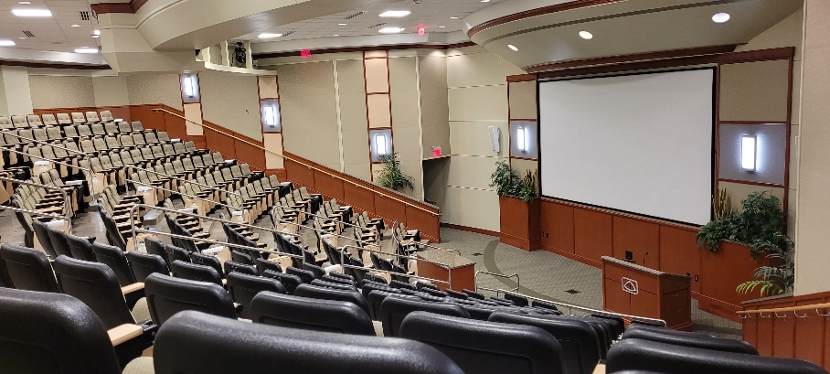
Dr. H. Edward Garrett, Sr. Auditorium
The facility´s centerpiece is the Garrett Auditorium, named in honor of Dr. H. Edward Garrett, Sr., who was on the surgical team that performed the world´s first successful coronary artery bypass graft in 1964. Dr. Garrett´s name represents true pioneering in the field of health care, as well as Baptist´s ongoing commitment to medical education and innovation.
Garrett Auditorium
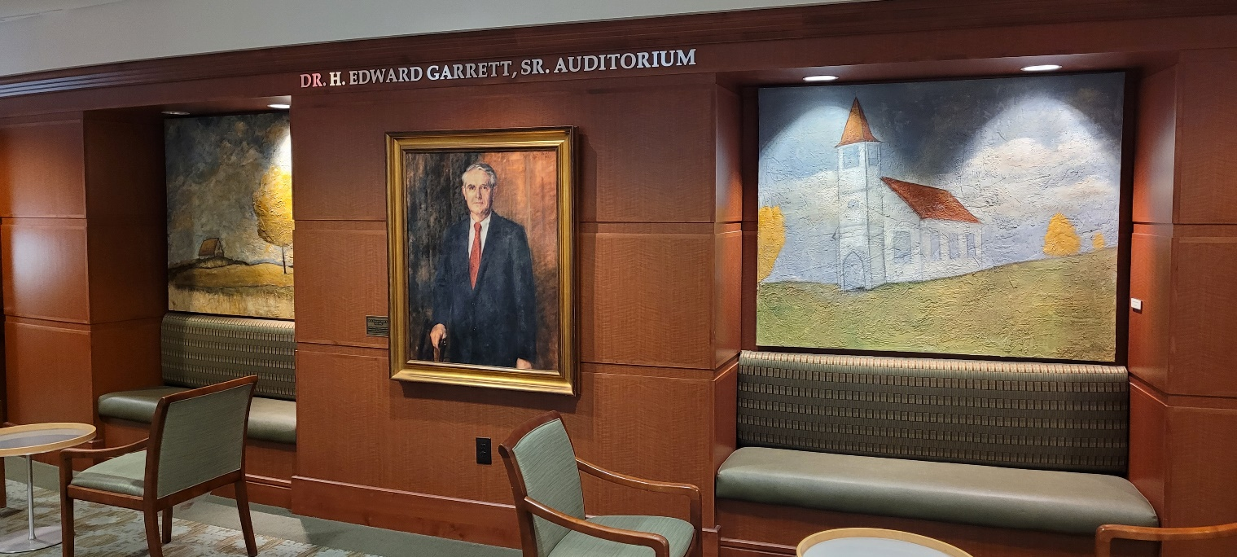
The 250-seat auditorium is equipped with advanced audio/visual capabilities to enable all forms of presentation media, teaching approaches, and communication avenues. Presentations originating from the Garrett Auditorium may be broadcast to all of the hospitals in the Baptist system.

Libraries

Maury W. Bronstein Health Sciences Library
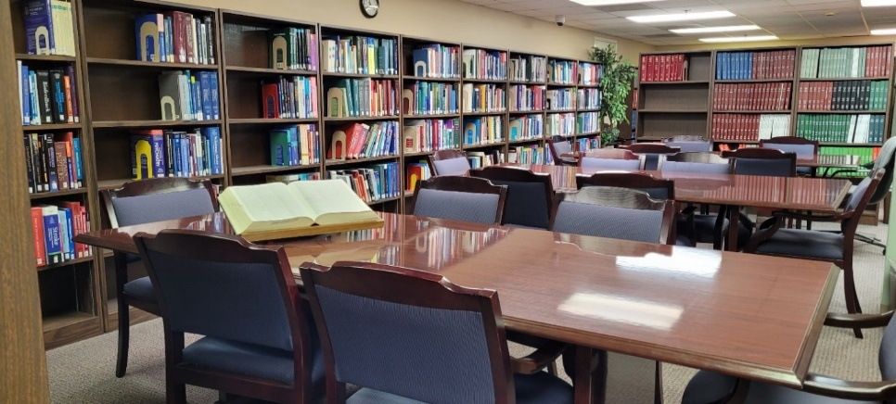
The Bronstein Library at Baptist Memphis provides resources and services to support the information and educational needs of faculty, residents, and rotating medical students. Our librarians are available to perform article or topic searches free of charge. They are able to access most articles and journals through many subscriptions and interlibrary exchange programs.
Books
The library's book collection consists of reference books, which may be used in the library, and other medical books that may be checked out for up to two weeks.
The Bronstein Medical Staff Library provides plenty of room for study & collaboration
Journals
The Bronstein Library subscribes to more than 60 medical and nursing journals, which are arranged on the shelves in alphabetical order. The Journal Holdings List is an alphabetical compilation of the journals in our library and is available electronically upon request. In addition, many of our journals can be accessed online.
The Bronstein Library at Baptist Memphis provides resources and services to support the information and educational needs of faculty, residents, and rotating medical students. Our librarians are available to perform article or topic searches free of charge. They are able to access most articles and journals through many subscriptions and interlibrary exchange programs.
Online Databases
Due to our extensive online resources, if you need an article you will almost always hear, “If you need it, I can get it.” Turnaround times for requested articles are usually two days and may be picked up in the library or sent to you via email.

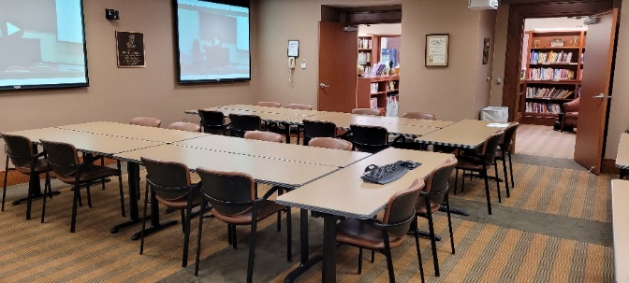
Ann L. and Joseph H. Powell Library (BMH-Memphis)

The Ann L. and Joseph H. Powell Library is a unique Consumer Library dedicated to educating our patients, families, and the public on a variety of health-related topics. This library contains books, periodicals, DVDs, anatomical models, and other educational materials, most of which are available for check-out. This 2,000-square-foot consumer library also features a meeting room complete with video teleconferencing which may be reserved for resident study groups and program meetings.
The Powell Library Conference Room set up for Conference
This free library will be greatly appreciated by your patients and patient families when they are looking for additional information about a diagnosis or procedure. Don’t hesitate to refer your patients to the Powell Library when they want to do additional research on their own.
This small library offers comfortable reading areas

Research
Research is a vital aspect of the health care industry. Baptist is committed to improving patient care through world-class research. Baptist physicians, fellows, residents, and medical students conduct in-depth research in many areas to help determine the safety and effectiveness of new treatments, medications and devices. Some of our key areas of research are cardiology, emergency medicine, endocrinology, oncology, neurosciences, and pulmonary medicine.

Baptist Clinical Research Institute
The Baptist Clinical Research Institute (BCRI) conducts inpatient and outpatient phase I through IV clinical trials to assist in the development of innovative medical care for patients. Our experienced study management team combined with a strong vision for the future and dedicated investigators ensure an effective trial process.

Baptist Institutional Review Board
The Baptist Memorial Health Care Corporation-Institutional Review Board (Baptist IRB) is a committee of physicians, statisticians, researchers, community advocates and others that ensures a clinical trial is ethical and the rights of study participants are protected. By federal regulation, all clinical trials in the U.S. must be approved by an IRB before they begin. At Baptist, the IRB initially approves and periodically reviews the research in order to protect the rights of human participants. All research studies performed using any Baptist facility must be reviewed and approved by the Baptist IRB.

Baptist Cancer Center
The Baptist Cancer Center (BCC) conducts clinical trials to ensure the advancement of our research efforts to help expand and improve our approach to cancer treatment. The cancer clinical trials cover a variety of cancers including lung oncology, breast oncology, head and neck oncology, experimental therapeutics program and malignant hematology program. Should you choose to complete one of your scholarly activities on a cancer-related topic, you may choose to work with the BCC. The Baptist Cancer Center is an NCI Community Oncology Member and is actively involved with Southwest Oncology Group that helps conceptually develop and implement active clinical studies sponsored by the NCI.

Other Baptist Research Sites
In addition to the BCC, the following clinics are dedicated to improving patient care through robust, innovative research.
- Baptist Medical Group - Endocrine Clinic
- Stern Cardiovascular Center
- Electronic Medical Record Platform (EMR)
All Baptist hospitals and BMG clinics utilize EPIC as our Electronic Medical Record platform. EPIC ties physicians and hospitals together and extends that access into the community. Branded Baptist OneCare, we believe that Epic is the best strategic solution for the entire Baptist enterprise. Epic is the preferred electronic medical record system used by more than 250 health care organizations nationwide. We are thrilled to provide this EMR for all of our residency and fellowship programs.

About Us: Our Partner Sites

Baptist Memorial Hospital – DeSoto
Baptist Memorial Hospital-DeSoto is a 339-bed acute care hospital located in Southaven, Mississippi. Our physicians provide a wide range of health care services, including cancer, heart, neurology, women’s and children’s services. Baptist-DeSoto was the first hospital in DeSoto County to offer open-heart surgery.

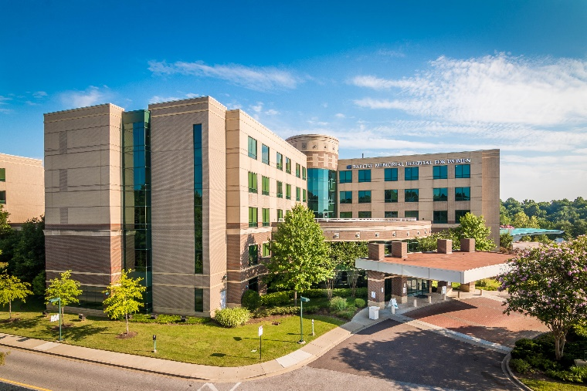
Baptist Memorial Hospital for Women and the Baptist-Spence and Becky Wilson Children’s Hospital
Baptist Memorial Hospital for Women (BMH4W) is the only freestanding women’s hospital in Memphis and one of only a handful of such hospitals in the country. Opened in 2001, Baptist Women’s Hospital is a regional referral center for high-risk pregnancies, mammography diagnostics, and urogynecology.
Designed to meet the needs of women at every stage of their lives, the 140-bed hospital is located adjacent to the Baptist Memorial Hospital-Memphis campus. With more than 800 physicians and 330 clinical professionals on staff, Baptist Women’s Hospital is well equipped to provide quality health care to women across the Mid-South.
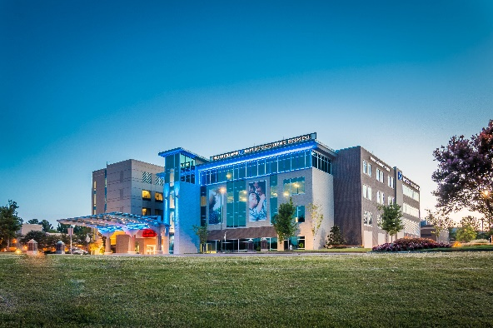
The Baptist-Spence and Becky Wilson Children’s Hospital is located adjacent to BMH Hospital for Women. It opened in January 2015. It offers Inpatient and Outpatient Pediatric Surgical Services as well as emergency services. Since its inception in 2015, this pediatric hospital has expanded to include a 10-bay Pediatric ER, 12-bed PICU and a 40-bed Level II NICU.

Baptist Memorial Hospital – Union County
Baptist Memorial Hospital-Union County is a 92-bed hospital in New Albany, Mississippi - a bit more than an hour from BMH Memphis. We serve the surrounding New Albany and the surrounding counties, and consistently have some of the highest quality metrics across our state. New Albany has a population of around 8,000 and has received many accolades for being a charming southern town.
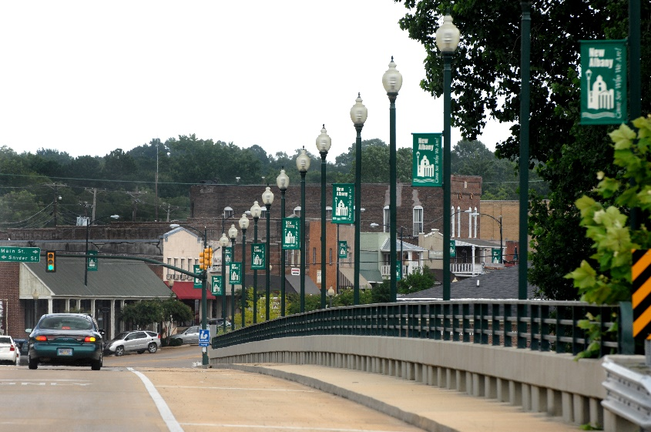
Our general surgeons’ practice encompasses a wide variety of general surgical procedures including “bread and butter” general surgery, advanced laparoscopy, and office-based procedures. Working in a more rural setting, our practice encompasses a good deal of gastroenterology including GI bleeding, surgical oncology, dermatology, wound care, podiatry, pediatrics, and critical care. We also do single-site laparoscopic cholecystectomy and laparoscopic transcystic common bile duct exploration. We were the first hospital in the state to use electrohydraulic lithotripsy for the latter procedure. Our local trauma system diverts to a level 2 trauma center located 25 minutes from here, which decreases out call responsibilities compared to those in a larger setting, although we still get our share of acute care surgery.
Entrance to Historic Downtown New Albany, MS
Practice philosophy: Treat the patient how you would want to be treated. We are heavily invested in our local area and in our hospital, so we are keenly interested in quality and excellence outcomes, professionalism, and compassionate care. We want our residents to learn how to work in a more resource-constrained setting and to be proficient in high-quality endoscopy including some difficult polypectomies and other endoscopic interventions. We expect them to branch out into the other disciplines mentioned above, and to continue their development by seeing and performing core general surgical procedures and patient management in a way that may be different compared to urban medicine.

Vanderbilt University Medical Center
The Baptist General Surgery residency is excited to partner with Vanderbilt University Medical Center for rotations in adult Trauma/Critical Care and Solid Organ Transplantation. Baptist residents with rotate with the Vanderbilt Trauma team for one month during the PGY1 year and two months during both the PGY2 and PGY4 years. Baptist residents will receive a comprehensive experience during the PGY1 year on solid organ transplant surgery with a focus on patient assessment, post-operative management and instruction in transplant immunology and immunosuppression. The PGY2 experience will focus on trauma patient assessment and the management of critically injured patients. The PGY 4 year will focus on advanced surgical techniques for injury management and trauma team leadership. While rotating at Vanderbilt, Baptist residents will function as full house staff members and attend Vanderbilt surgical conferences relevant to the educational experience. Additionally, residents will receive full housing and travel support for time away in Nashville.


Your 2025 Benefits Options
- Health Insurance
- Dental Insurance
- Vision Insurance
- Employer-Provided Life Insurance
- Voluntary Life Insurance
- Sick Pay Benefit (SPB)
- Employer-Provided Long-Term Disability
- Short Term Disability
- Hospital Indemnity Insurance
- Critical Illness Insurance
- Accident Insurance
- Cancer Advocate Plus
- Life Insurance with Long Term Care Coverage
- ID Theft Protection
- Legal Plans
- Pet Insurance
Benefits are subject to change.
Human Resources
Memphis Hospital
6025 Walnut Grove Road, 1st floor Suite 101
Memphis, TN 38120
Ofc: 901-226-5020
Fax: 901-226-5911

SELECTED GME POLICIES

BAPTIST MEMORIAL MEDICAL EDUCATION

DEPARTMENTAL POLICY AND PROCEDURE MANUAL
Effective Date: July 2013 | Resident/Fellow Selection Guidelines  Applicant Eligibility:  Baptist-employed Residents/Fellows
Last Review/Revision: December 2020
Reference #: -

PURPOSE: To establish a policy for resident selection that complies with the Accreditation Council for Graduate Medical Education (ACGME)
POLICY: Resident/Fellow Selection Guidelines
ACGME Common Program Requirements Citation (effective 7/1/2020):
RESIDENCY
III.A. Eligibility Requirements
III.A.1. An applicant must meet one of the following qualifications to be eligible for appointment to an ACGME-accredited program: ^{(Core)}
III.A.1.a) graduation from a medical school in the United States or Canada, accredited by the Liaison Committee on Medical Education (LCME) or graduation from a college of osteopathic medicine in the United States, accredited by the American Osteopathic Association Commission on Osteopathic College Accreditation (AOACOCA); or, ^{(Core)}
III.A.1.b) graduation from a medical school outside of the United States or Canada, and meeting one of the following additional qualifications: ^{(Core)}
III.A.1.b).(1) holding a currently valid certificate from the Educational Commission for Foreign Medical Graduates (ECFMG) prior to appointment; or, ^{(Core)}
III.A.1.b).(2) holding a full and unrestricted license to practice medicine in the United States licensing jurisdiction in which the ACGME-accredited program is located. ^{(Core)}
III.A.2. All prerequisite post-graduate clinical education required for initial entry or transfer into ACGME-accredited residency programs must be completed in ACGME-accredited residency programs, AOA-approved residency programs, Royal College of Physicians and Surgeons of Canada (RCPSC)-accredited or College of Family Physicians of Canada (CFPC)-accredited residency programs located in Canada, or in residency programs with ACGME International (ACGME-I) Advanced Specialty Accreditation. ^{(Core)}
III.A.2.a) Residency programs must receive verification of each resident’s level of competency in the required clinical field using ACGME, CanMEDS, or ACGME-I Milestones evaluations from the prior training program upon matriculation. ^{(Core)}
[The Review Committee may further specify prerequisite postgraduate clinical education]
III.A.3. A physician who has completed a residency program that was not accredited by ACGME, AOA, RCPSC, CFPC, or ACGME-I (with Advanced Specialty Accreditation) may enter an ACGME-accredited residency program in the same specialty at the PGY-1 level and, at the discretion of the program director of the ACGME-accredited program and with approval by the GMEC, may be advanced to the PGY-2 level based on ACGME Milestones evaluations at the ACGME- accredited program. This provision applies only to entry into residency in those specialties for which an initial clinical year is not required for entry. ^{(Core)}
FELLOWSHIP
III. Fellow Appointments
III.A. Eligibility Criteria
III.A.1. Eligibility Requirements – Fellowship Programs
[Review Committee to choose one of the following:]
Option 1: All required clinical education for entry into ACGME-accredited fellowship programs must be completed in an ACGME-accredited residency program, an AOA-approved residency program, a program with ACGME International (ACGME-I) Advanced Specialty Accreditation, or a Royal College of Physicians and Surgeons of Canada (RCPSC)-accredited or College of Family Physicians of Canada (CFPC)-accredited residency program located in Canada. ^{(Core)}
Option 2: All required clinical education for entry into ACGME-accredited fellowship programs must be completed in an ACGME-accredited residency program or an AOA-approved residency program. ^{(Core)}
III.A.1.a) [If Review Committee selected Option 1 above:]
Fellowship programs must receive verification of each entering fellow’s level of competence in the required field, upon matriculation, using ACGME, ACGME-I, or CanMEDS Milestones evaluations from the core residency program. ^{(Core)}
[If Review Committee selected Option 2 above:]
Fellowship programs must receive verification of each entering fellow’s level of competence in the required field, upon matriculation, using ACGME Milestones evaluations from the core residency program. ^{(Core)}
III.A.1.b) [The Review Committee must further specify prerequisite postgraduate clinical education]
PROCEDURE:
Only the following individuals will be considered as applicants in residency and fellowship programs at Baptist Memorial Health Care Corporation:
- Applicants graduated or pending graduation from a Liaison Committee on Medical education (LCME)-approved U.S. and Canadian Medical Schools
- Applicants graduated or pending graduation from an AOACOCA-accredited (American Osteopathic Association Commission on Osteopathic College Accreditation) medical schools
- Applicants graduated or pending graduation from an International Medical Schools who are expected to, before the planned matriculation date, have a valid Education Commission for Foreign Medical Graduates (ECFMG) certificate or a full and unrestricted license to practice medicine in a United States licensing jurisdiction in which they are in training
Only graduates of schools that are recognized by the Medical Board of California will be considered for residency positions within the Baptist system. This list can be found at
https://www.mbc.ca.gov/Applicants/Schools_Recognized/
Only applicants who are or will be within their initial residency period as defined by the Centers for Medicare & Medicaid Services (CMS) will be considered for positions in any ACGME-approved residency program in the Baptist Memorial Health Care system.
Applicants with the following US Residency statuses will be considered for available residency or fellowship positions within the Baptist system:
- US Citizen
- Legal Permanent Resident (“Green card Holder”)
- Employment Authorization Document (EAD) resulting from application for Permanent Residency
- Foreign National with valid Visa permitting employment with Baptist
- J-1 visa sponsored through ECFMG
Application Process & Interviews
- All routine applications will be processed through the Electronic Residency Application Service (ERAS) when available
- Positions that become available “off-cycle” may be filled outside of the MATCH only if the timing of the availability of these positions and a delay caused by the length of time to the next MATCH will cause a hardship on the Program
- Opportunities for interviews will be extended to applicants based on their qualifications including USMLE scores, medical school performance, letters of recommendation, history of previous residencies / fellowships served, program preferences, and as determined by citizenship/ residency status as identified above
National Resident Matching Program (NRMP) & Rank Order Process
- BMME agrees to the NRMP “All-In” policy, participating in the NRMP MATCH when available and will only consider applicants to MATCH-eligible programs through ERAS
- All eligible, interviewed applicants will be considered for ranking in the MATCH in order of preference based on the following criteria: qualifications as stated above, preparedness, ability, aptitude, academic credentials, board scores, communication skills, and personal qualities such as motivation and integrity.
- Characteristics such as gender, age, religion, ethnicity, national origin, disability, veteran status, or any other classification protected by federal, state, constitutional, or statutory law will not be used in the selection procedure. Baptist is an Equal Opportunity Employer.
- Evaluations and recommendations of all interviewing faculty, residents, and other staff will be considered in determining the rank order of the interviewed applicants.
Program Appointments
- Appointments to our programs will be issued to all matched applicants who meet employment eligibility requirements.
- Following release of the MATCH results, attempts will be made to fill any vacant positions in accordance with the terms of our agreement with the NRMP.
- Employment Agreements for all positions will be issued through the Graduate Medical Education Office following a successful MATCH, or off-cycle or advanced program-year selection.

Exclusions
All residents and fellows must qualify for employment with Baptist Memorial Health Care. Some requirements for employment include a negative drug screen, clear criminal background check and the ability to participate in the federal healthcare programs (see additional info below). In addition, any resident who is required by their program to obtain and maintain a medical license in the State of Mississippi must successfully complete Step III by the end of his or her PGY-2 year in order to maintain eligibility for employment by Baptist.
Baptist will review the Office of Inspector General (OIG) and System for Award Management System (SAMS) databases to ensure that all applicants who are included in each program’s MATCH list are not listed. The OIG list contains the names of parties convicted of “program-related fraud and patient abuse, licensing board actions and default on Health Education Assistance Loans.” The SAMS list provides an up-to-date source of information on those firms and individuals that have been suspended, debarred or otherwise excluded from Federal Procurement and Nonprocurement Programs. Baptist will not employ anyone who has been suspended, debarred, or excluded from participation in government-sponsored programs.

Exceptions
Exceptions to the Residency Selection Guidelines may be considered for approval by Baptist Memorial Medical Education Graduate Medical Education Committee on a case-by-case basis provided funding can be secured.

From ACGME Common Program Requirements effective 7/1/2020
RESIDENCY EXCEPTIONS
III.A.4.a) An ACGME-accredited residency program may accept an exceptionally qualified international graduate applicant who does not satisfy the eligibility requirements listed in III.A.1.- III.A.3., but who does meet all of the following additional qualifications and conditions: ^{(Core)}
III.A.4.a).(1) evaluation by the program director and residency selection committee of the applicant’s suitability to enter the program, based on prior training and review of the summative evaluations of this training; and, ^{(Core)}
III.A.4.a).(2) review and approval of the applicant’s exceptional qualifications by the GMEC; and, ^{(Core)}
III.A.4.a).(3) verification of Educational Commission for Foreign Medical Graduates (ECFMG) certification. ^{(Core)}
III.A.4.b) Applicants accepted through this exception must have an evaluation of their performance by the Clinical Competency Committee within 12 weeks of matriculation. ^{(Core)}
FELLOWSHIP EXCEPTIONS
III.A.1.c) Fellow Eligibility Exception
The Review Committee for ______ will allow the following exception to the fellowship eligibility requirements:
[Note: Review Committees that selected Option 1 will decide whether or not to allow this exception. This section will be deleted for Review Committees that do not allow the exception and for Review Committees that selected Option 2]
III.A.1.c).(1) An ACGME-accredited fellowship program may accept an exceptionally qualified international graduate applicant who does not satisfy the eligibility requirements listed in III.A.1., but who does meet all of the following additional qualifications and conditions: ^{(Core)}
III.A.1.c).(1).(a) evaluation by the program director and fellowship selection committee of the applicant’s suitability to enter the program, based on prior training and review of the summative evaluations of training in the core specialty; and, ^{(Core)}
III.A.1.c).(1).(b) review and approval of the applicant’s exceptional qualifications by the GMEC; and, ^{(Core)}
III.A.1.c).(1).(c) verification of Educational Commission for Foreign Medical Graduates (ECFMG) certification. ^{(Core)}
III.A.1.c).(2) Applicants accepted through this exception must have an evaluation of their performance by the Clinical Competency Committee within 12 weeks of matriculation. ^{(Core)}

BAPTIST MEMORIAL MEDICAL EDUCATION
DEPARTMENTAL POLICY AND PROCEDURE MANUAL
Effective Date: July 2013 | Resident Visa Policy  Baptist-employed Residents
Last Review/Revision: January 2020 | Resident Visa Policy  Baptist-employed Residents
Reference #: - | Resident Visa Policy  Baptist-employed Residents

PURPOSE: To establish a policy for resident visas that complies with the Accreditation Council for Graduate Medical Education guidelines

POLICY: Resident Visa Policy

PROCEDURE:
Baptist will not petition for visas with rare exception.

NOTES:

